MODULE 4 – INTRODUCTION TO DBMS

LAB EXERCISES

1. Introduction to SQL
Lab 1.
Create a new database named school_db and a table called students with the following columns – student_id, student_name, age, class and address.
Ans.
Create a database names school_db
1. CREATE DATABASE school_db
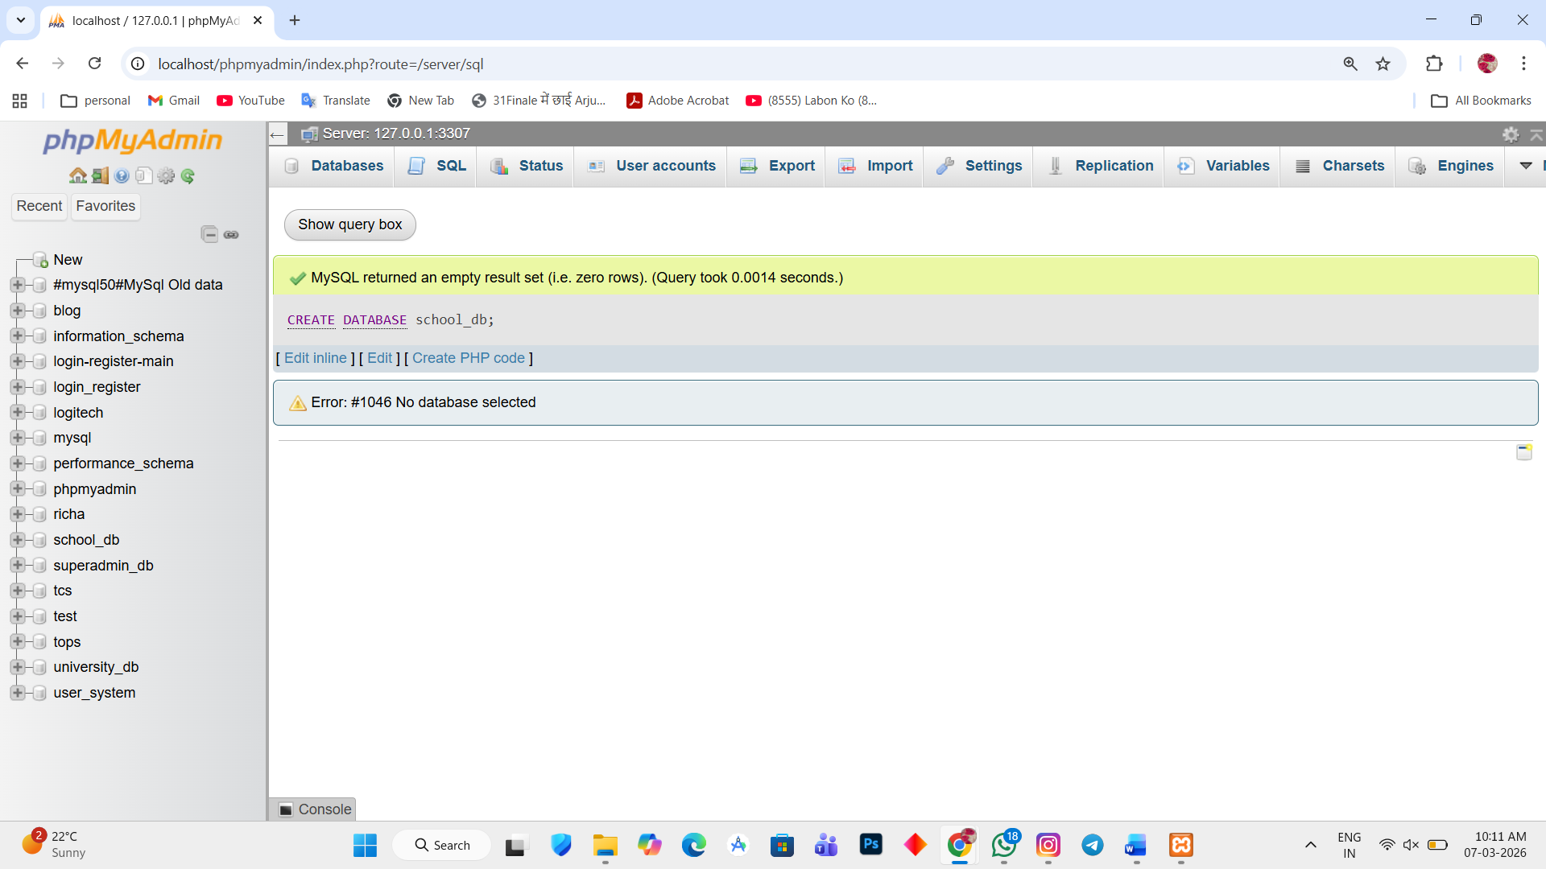

2. CREATE TABLE student(student_id int PRIMARY KEY AUTO_INCREMENT, student_name varchar(255), age int, class varchar(255), address varchar(255))
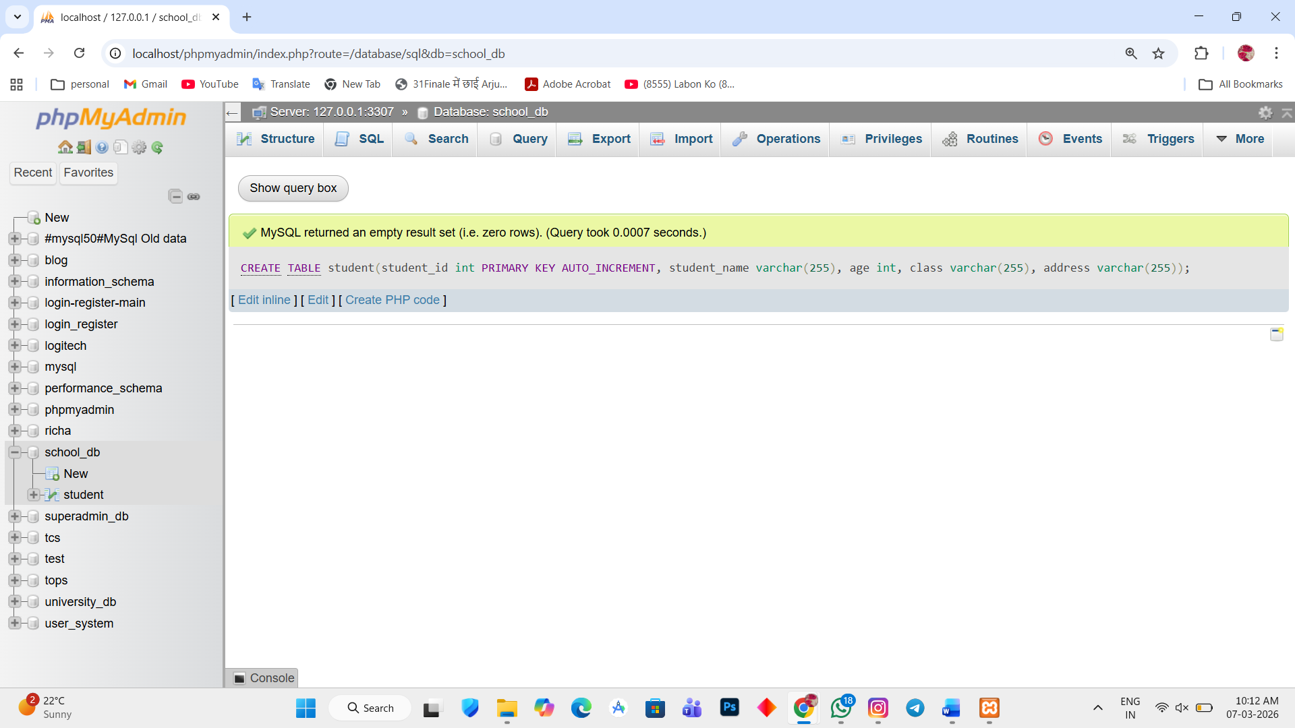

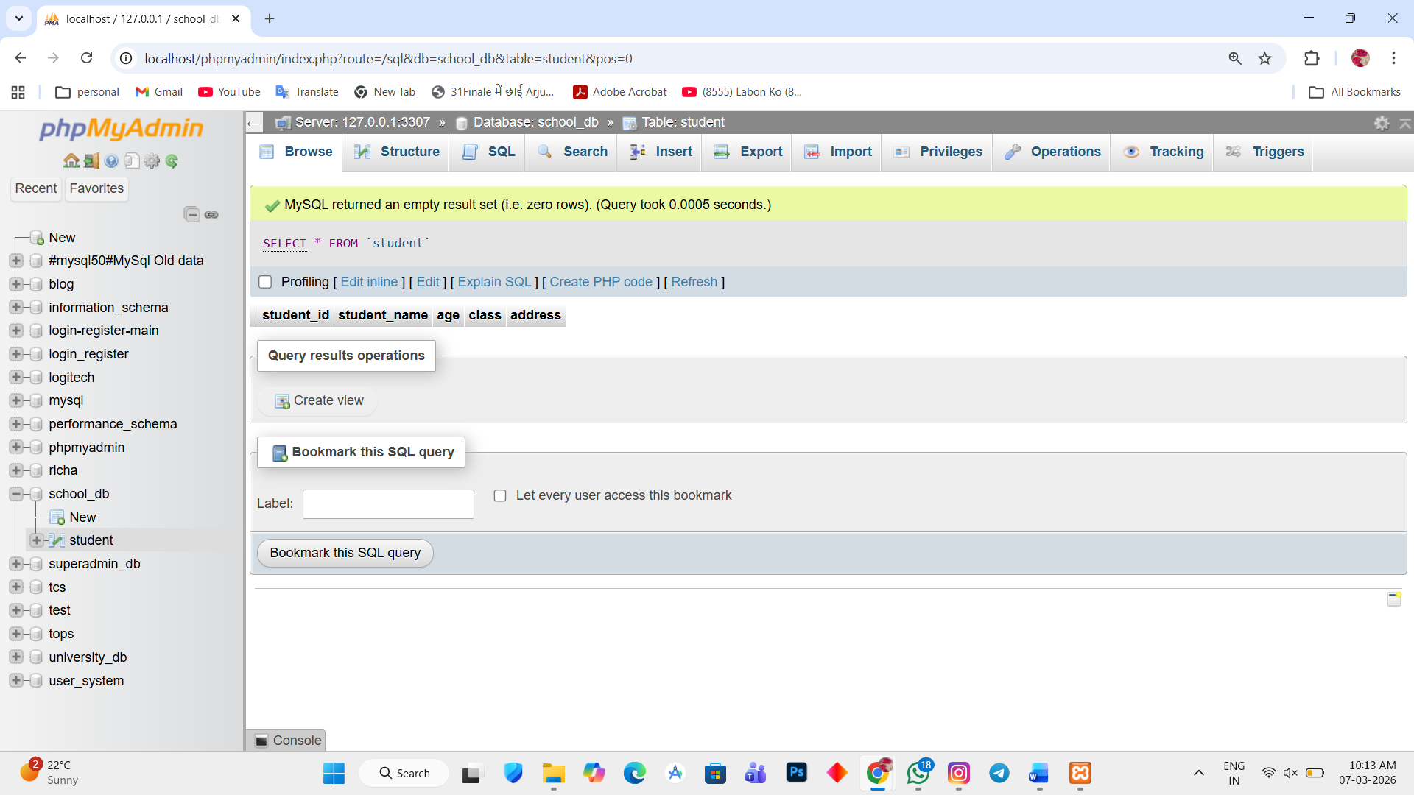

Lab 2.
Insert five records into the students table and retrieve all records using the SELECT statement.
Ans.
1. INSERT INTO student(student_name, age, class, address) VALUES ('Richa', '21', '10th', 'Bajrangwadi'),
('Purvi', '15', '8th', 'Baktinagar'), ('Vaibhav', '17', '12th', 'Champaknagar'), ('Jatin', '22', 'Graduate', 'Railnagar'), ('Himshikha', '25', 'Graduate', 'Kalawad road');
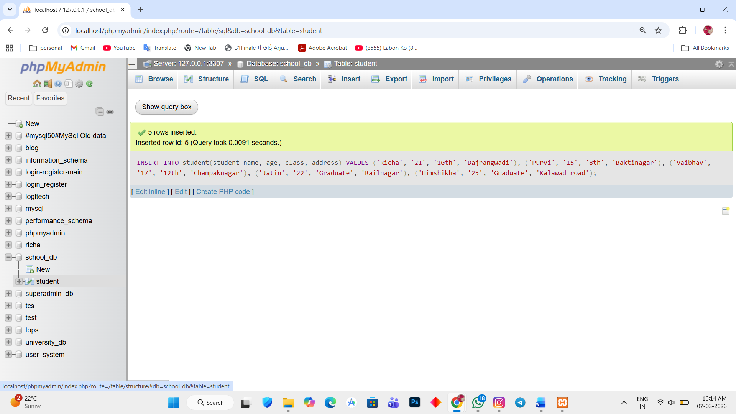

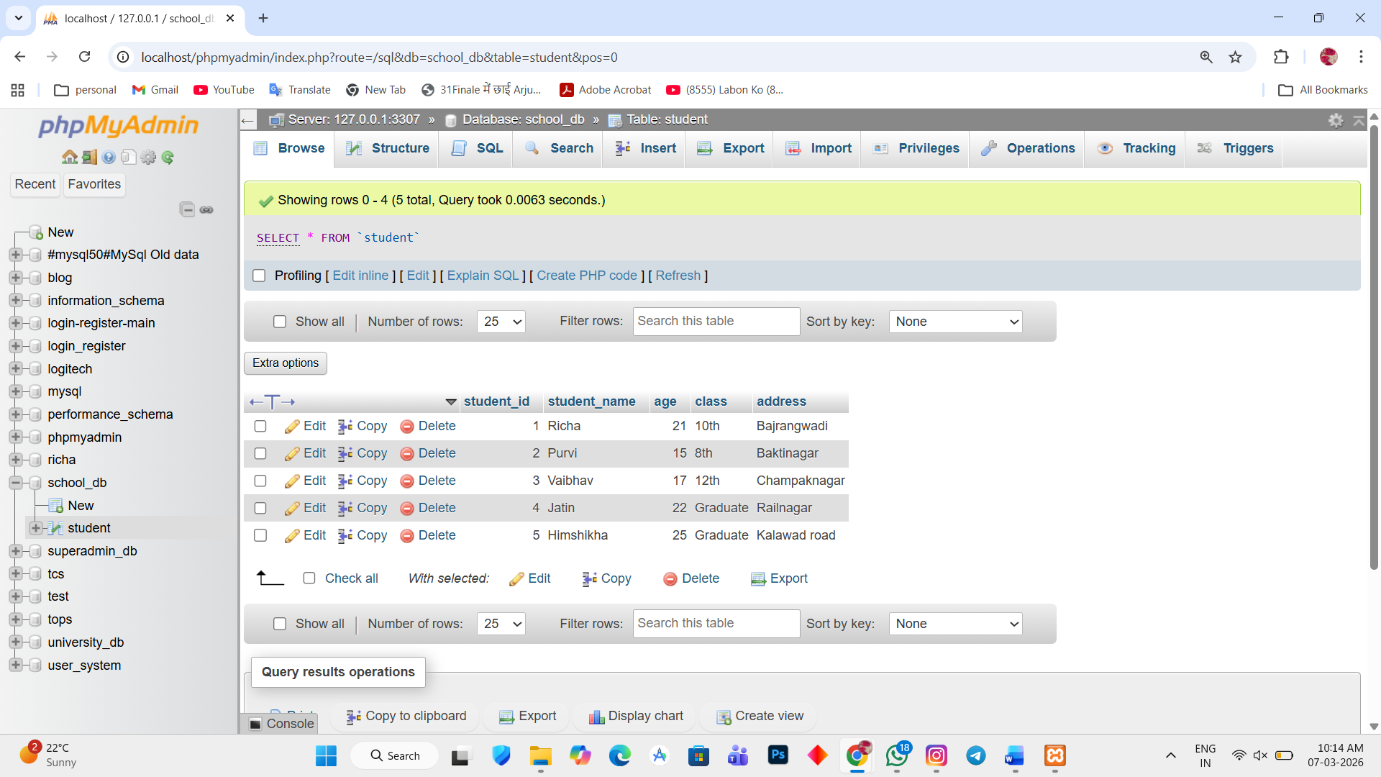

2. SELECT * FROM `student`
